Educational Pearls that can Help You with Tutorials

I hope some of the theoretical stuff below will help you (the trainer/educator) think about the way in which you are currently delivering tutorials and help you think of ways to tweak them to make them have more educational impact.
You will have come across some of the material below, but there are other parts that will be new to you which I hope will trigger new thoughts and creativity. Please try and read through it all and jot down any thoughts that might make your tutorial giving even better on a separate piece of paper.

Ramesh Mehay
Programme Director (Bradford VTS)

Pearl 1: Engaging in Adult Learning (=Andragogy, pronounced an-druh-goh-jee)
Andragogy is defined as “any intentional and professionally guided activity that aims at a change in adult persons” (Knowles, Holton, & Swanson, 2005, p. 60). And by change we mean a change in knowledge, skills, attitudes and behaviour in an individual.

In contrast, pedagogy embodies teacher focussed education: learning is based on the teacher’s rather than the learner’s agenda: the teacher has full responsibility for making decisions about what will be learned, how it will be learned and when it will be learned. Learners assume a submissive obedient role and are dependent on the teacher. Andragogy and pedagogy are best seen NOT as separate entities but as two ends of a spectrum: what methods of each you wish to employ depends on your target audience and the educational objectives set.

If we subscribe to the core principles of adult learning, then
- adults learn best
- it’s really stimulating for them and
- both they and educators have fun in the process.

Knowles’ Principles of Adult Learning (1984)

1. NEED TO KNOW (goal orientated)
Adults need to know why they need to learn something or how it will benefit them; how it will meet their future goals. Survey the learners to help identify their learning needs; what will help them?
2. SELF-CONCEPT (autonomous, independent, self directed)
As adults develop self concept, they move from being dependant to independent learners. Treat learners as equals with respect. Encourage them to do some self directed learning. Encourage them to be creative and independent.
3. ROLE OF EXPERIENCE (connecting knowledge to experience)
Adults come with a reservoir of experiences which should be used & weaved into new learning but remember: some of those experiences are biased and are assumptions
“reflective learning becomes transformative whenever assumptions or premises are found to be distorting, inauthentic or otherwise invalid.” (Mezirow, 1991)
So: use case studies, reflective activities, problem based learning etc; explore their habits & biases
4. READINESS TO LEARN
In other words, adults are ready to learn those things they need to know in order to cope effectively with real life problems and tasks. Try and organise learning programmes around life experience: uses real or near real case examples for them to work on which they can relate to

Brookfield’s Principles of Adult Learning (1990)
Brookfield created principles not too dissimilar from Knowles’ work. However, he places greater emphasis on: collaboration, praxis and critical reflection.
- Adult education can and should be viewed as a collaborative activity. Involve the rest of your audience as much as possible when trying to construct learning.
- That learning should involve a critical reflection of the basis of one’s beliefs

Vella's 12 Principles for Effective Adult Learning (1994)
- Needs Assessment: learners need to participate in what is to be learned
- Sequence & reinforcement: carefully sequence what you are trying to teach in a logical way and reinforce key elements to help learners remember
- Action with reflection (praxis): Praxis is a continual process of activity, followed by reflection, refinement and then implementation; Experience + Reflection = Learning (Dewey, 1938). Encourage a continual process of activity, followed by reflection, refinement and then implementation (similar to Kolb’s learning cycle below);
- Learners as subjects of their own learning: respect learners as decision makers which inevitably means you need to give them autonomy (freedom to be creative)
- Learning with ideas, feelings, actions: means exploring knowledge, skills and attitudes
- Immediacy: not only does learning have to be useful, it also has to be transferable to real life situations one is likely to encounter in the near future
- Clear roles: teacher and learner(s) must know their own and each other’s role in the learning process. For example, does the teacher give the impression of being an ‘expert’ who is not to be questioned or disputed with? Or are learners free to debate or disagree?
- Teamwork: encourage collaboration, for example, through small group work
- Engagement: of the learners in what they are learning.
- Accountability: you need to do some sort of evaluation or monitoring to check they are learning what was intended

Billington’s 7 Characteristics of Highly Effective Adult Learning Programs (1988)
Now that we know something about Knowles’ and Brookfield’s principles of adult learning we can work out the essential ingredients for making an adult educational session work:
- An environment where students feel safe and supported, where individual needs and uniqueness are honoured; where learns feel comfortable with revealing their true inner feelings. An environment that fosters intellectual freedom and encourages experimentation and creativity.
- An environment where faculty treats adult students as peers - accepted and respected as intelligent experienced adults whose opinions are listened to, honoured and appreciated. Such faculty members often comment that they learn as much from their students as the students learn from them.
- Self-directed learning, where students take responsibility for their own learning. Even designing their own individual learning programs which address what each person needs and wants to learn in order to function optimally in their profession.
- Pacing or intellectual challenge. Optimal pacing is challenging people just beyond their present level of ability. If challenged too far beyond, people give up. If challenged too little, they become bored and learn little. Pacing can be compared to playing tennis with a slightly better player; your game tends to improve. But if the other player is far better and it's impossible to return a ball, you give up, overwhelmed. If the other player is less experienced and can return none of your balls, you learn little. Those adults who reported experiencing high levels of intellectual stimulation (to the point of feeling discomfort) grew more.
- Active involvement in learning, as opposed to passively listening to lectures. Where students and instructors interact and dialogue, where students try out new ideas in the workplace, where exercises and experiences are used to bolster facts and theory, adults grow more.
- Regular feedback: get feedback from students to tell you (the educator) what works best for them and what they want and need to learn; and you, the trainer/educator, needs to hear and make changes based on student input.

Pearl 2: Employing the 3 C’s of Constructivism (Construction, Context & Collaboration)
Constructivism is attributed to a number of originators: Vico (1700s), Dewey (1938), Piaget (1950) and Vygotsky (1978). Vico’s verum factum principle (1710) states that truth is verified through creation or invention and not, as per Descartes’ previously held belief, through observation (Croce, 1913). The three Cs of constructivism are:

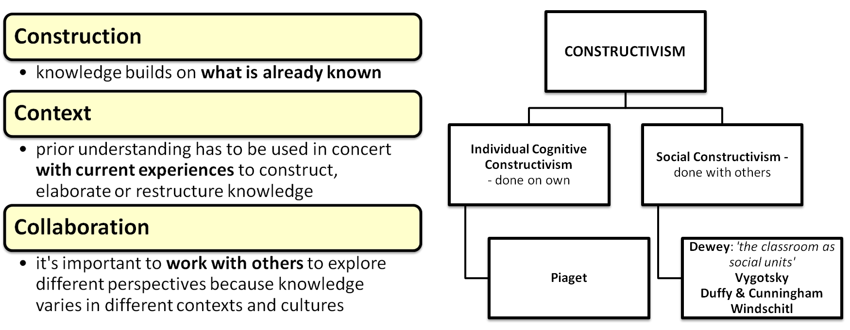
Only by wrestling with the conditions of the problem at hand, seeking and finding his own solution (not in isolation but in correspondence with the teacher and other pupils) does one learn.
(John Dewey, How We Think, 1910)

Constructivism is based on the theory that people learn best by actively constructing their own concepts, ideas and understanding usually by fitting new information together with what they already know; its emphasis is on the learner rather than the educator. For example, if you give a group of adults a novel to read, and then ask them to describe it, they’ll come up with their own different interpretations. Therefore, one of the most fundamental principles of constructivism is that there are no universal truths and that meaning is socially negotiated* (Duffy & Cunningham, 1996, and Windschitl, 2002): something educators often have difficulty adopting. Constructivism emphasises the social nature of learning: the rich learning the group environment provides us with.
*= knowledge is seen entirely as a socially negotiated human construct which means the new knowledge they build is a result of social interaction and application within their environment

Caine & Caine’s 12 Principles of Constructivism
Constructivist teaching is based on learning mechanisms in the brain. Caine and Caine (1991) put forward 12 principles that augment these mechanisms:
- The brain is a parallel processor: our amazing brains can handle a whole host of information of differing nature at the same time (such as thoughts, feelings, knowledge etc.). Therefore, effective teaching must employ a variety of teaching methods to mirror this.
- Learning engages the entire physiology: meaning teaching has to encompass knowledge, skills, attitudes, culture and experience.
- The search for meaning is innate: every learner brings with them their own unique experiences which gives unique meaning to whatever ever is taught. The effective teacher needs to recognise and incorporate that experience into the educational session.
- The search for meaning occurs through 'patterning': to effectively teach, one has to connect isolated ideas to global concepts and themes. In other words: help establish a learning framework from which learners can hang things off.
- Emotions are critical to patterning: you need to incorporate emotions, feelings, and attitudes into any learning taking place.
- The brain processes parts and wholes simultaneously: you therefore need to look at both and not explore one at the expense of the other. So, link isolated ideas and knowledge to global concepts and themes at the right time.
- Learning involves both focused attention and peripheral perception: learning is influenced not only by the subject matter but also by the environment, culture, and climate; create a climate conducive to learning.
- Learning always involves conscious and unconscious processes: often, you’ll need to revisit an educational session after a certain period of time has elapsed to allow learners to ‘mull’ the learning over and give them a chance to try out new ideas.
- We have at least two different types of memory: a spatial memory system and a set of systems for rote learning: therefore teaching has to be balanced. If you provide too much rote learning and not provide enough room for experiential learning (spatial learning), true understanding can be seriously limited.
- We understand and remember best when facts and skills are embedded in natural, spatial memory: in other words, promote experiential learning
- Learning is enhanced by challenge and inhibited by threat: you need to challenge the learners without destroying them.
- Each brain is unique: which means each individual learner has an individual way of learning. Therefore, teaching must be offered in a variety of formats to enable learners to “cherry pick” what would work best for them.

How to Design a Classroom Based on Constructivism
A Traditional Classroom Teacher  Would Say: | A Constructivist Classroom Teacher  Would Say:
Curriculum begins with dividing the whole into parts and examining those parts i.e. examine the micro skills firsts | Examine the whole first and then derive the component parts: i.e. introduce concepts firsts
Stick to a rigid, fixed and defined curriculum | Go down the path where the learners take you: focus on their questions, interests and areas of unmet needs
Learning is based on repetition | Learning is interactive and based on building upon what learners already knows
Learners work mainly alone | Learners work mainly in groups
Educators impart information, learners are there to soak it all up | Educators interact with their learners and help them ‘construct’ their own knowledge
Educator is directive and authoritarian | Educator is on a level playing field, engages in dialogue with the learner(s) and negotiates the agenda
Knowledge is seen as inert | Knowledge is seen as dynamic; forever evolving with our experiences
Refer to books/workbooks where necessary | Refer to a variety of creative teaching material
Assessment is via knowledge tests e.g. true/false questions, recall of facts | Assessment is through work place based assessment i.e. what they do in real life as a result of the learning

How to Use This Model
So, whenever you’re running an educational session, it’s important to identify your learners’ prior understanding from real experiences first (contextual). Once you’ve identified that, you use methods that enable trainees to form build on this and form their own constructs. You need to start off with familiar ideas before introducing analogous ones (construction). Trainees should be encouraged to explore possibilities, try them out, rethink problems, and then hopefully they’ll come up with new concepts/solutions. For this to happen, they have to collaborate with others and you have to give them autonomy and encourage self initiative. However, you have to be on the ball and detect any misconceptions, errors and omissions so that you can correct them to enable them to make true meaning. Specific techniques which can aid this include:
- Aid understanding by organizing the concepts you present e.g. mindmaps etc
- Teaching by asking questions
- Get trainees to explain their understanding to each other
- Socratic questioning - use wrong answers to explore and correct misunderstandings.
- Use thought provoking tasks and questions that are high on Bloom’s Taxonomy (for Bloom, see Pearl 8): like “why” (analysing), “how could…” (creating) and “what do you think” (evaluating) questions
- Use case studies to encourage testing and questioning of newly formed concepts
- Promote group work requiring trainees to “check out” understanding with each other

Pearl 3: Using Reflective Learning Cycles

Gibb’s Reflective Cycle (1988)
Gibb’s cycle is a neat little tool because it provides you with a structure for tackling any case discussion learners have experienced – especially the emotionally charged ones. It encourages learners to reflect on what happened so that they can somehow make sense of the experiences. But reflection is not enough: one has to put the new learning and understanding into practise.

How to Use It
- Use the headings below to structure the reflective discussion around any experiential event.
- Use it to encourage trainees how to write up learning events for their e-portfolios.
- Make sure the learners are not too hard on themselves: the evaluation phase should help you tease what was GOOD and bad about the experience.

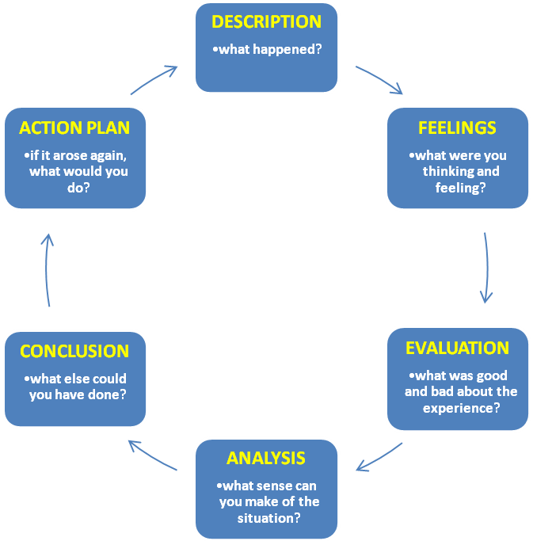

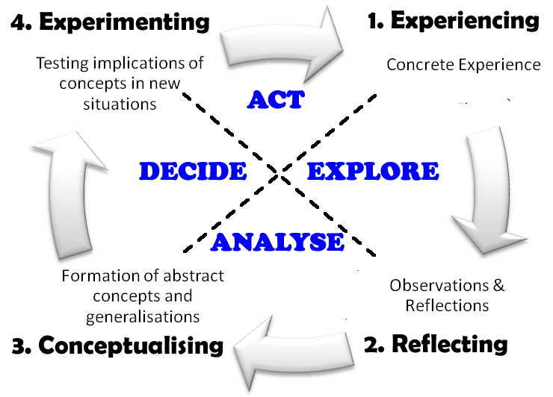
Kolb’s Learning Cycle (1984)
Kolb’s learning cycle is another model that you can use in a similar way to Gibb’s:

Principle 4: Enhance Motivation

The 6 C’s of Motivation (Turner & Paris, 1995)
These principles are based on the fact that people are more likely to get deeply involved in things that involve their own choices and goals. You still need to facilitate: keep an eye on their progress and help them work collaboratively with:
- making the most appropriate choice
- planning
- evaluating/providing feedback and
- constructing personal meaning through the task.

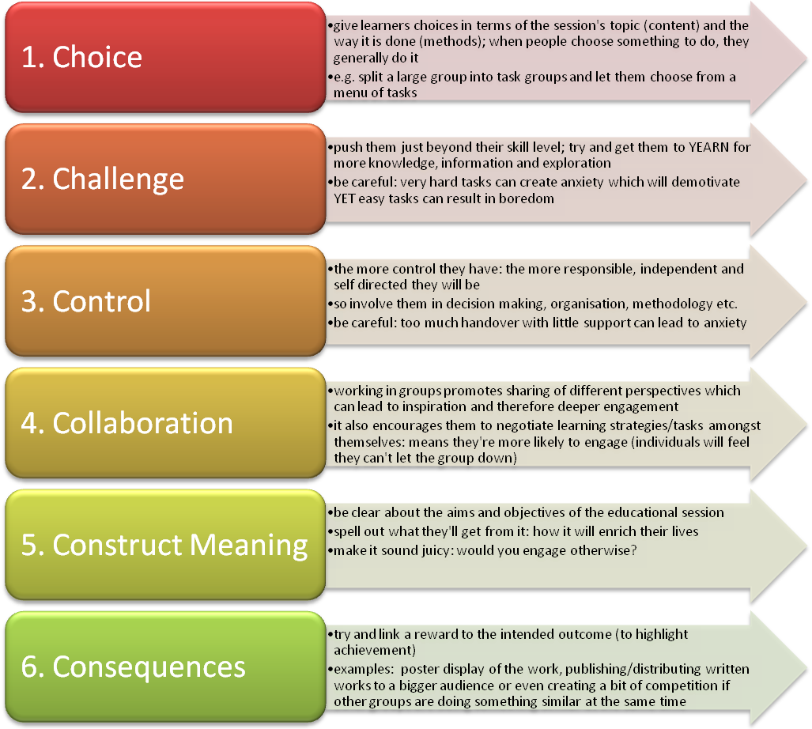

The ARCS Model for Motivation (Keller, 1987)
The ARCS model provides a simple framework of motivational techniques you can use throughout an educational session.

- Attention – ‘Hook’ the participants’ and stimulate an attitude of inquiry.
For example: ask questions; use their emotional or personal information; show relevance to their workplace.
- Relevance – making the educational session relevant to the learners’ needs.
Explore the experiences of the group and build on that. In essence: show them what’s in it for them.
- Confidence – create an educational ethos which promotes success: that they can do it and implement it back in the workplace environment.
Reinforce when they are doing things well. Urge them on. Your own positivity towards the task will infiltrate into others.
- Satisfaction – ensure they are enjoying the learning experience (you’ll need to revisit this periodically).
Check out what a difference the new learning will have for them on a personal level: a good place to do this is when giving them good feedback and in the summarising phase at the end.

Pearl 5: Teacher-Learner Styles

The Staged Self-Directed Learning (SSDL) Model (Grow 1991)
This model is based on Hersey and Blanchard’s work into ‘situational leadership’ (in ‘business management’) and translated by Gerald Grow to the educational setting. Its basic principle is that teaching is situational: the style of teaching needs to be matched to the learner's ability and motivation at the time (termed "readiness").

Grow proposed four learner styles and four matching teacher styles. You can only move trainees to the next level if you figure out where they currently are and match them first. The four levels are described below. Problems occur when dependent learners are mismatched with non-directive teachers and when self-directed learners are mismatched with highly directive teachers.

Therefore, the purpose of this model is to help you
- identify where your current learners are in terms of self-directedness
- match your educational activities/session to that level and then
- facilitate their progression to the next higher level.

Good teaching does two things: a) it matches the student's stage of self-direction, and b) it empowers the student to progress toward greater self-direction. Remember, moving the learner onto the next stages requires time; it doesn’t happen overnight! You need patience.

 | Student | Teacher | Examples | Possible Teacher Pitfalls
Stage 1 | Dependent | ‘The Expert’ | Coaching with immediate feedback. Drill. Informational lecture. Directive and pedagogical in nature. | Can be too controlling that stifles learner initiative and enhances dependency.
Stage 2 | Interested | Motivator | Inspiring lecture plus guided discussion. Goal-setting and learning strategies. | May end up entertaining well but leaving learners with little learning skills and/or motivation.
Stage 3 | Involved | Facilitator | Discussion facilitated by teacher who participates as equal. Collaborative small group work. Non directive and truly andragogical. | May end up accepting and valuing anything from anybody; students then show little respect.
Stage 4 | Self-directed | Delegator | Internship, dissertation, individual work or self-directed study-group. Creativity. Mentorship. | May withdraw too much and thus lose touch and fail to monitor progress.

More detail available at: http://www.longleaf.net/ggrow/SSDL/Model.html#Definition
Be careful of the ‘false’ stage 4 learner: appears like a stage 4 learner but is actually a dependent learner of stage 1 or 2 and can be identified by being fairly vocificerous and try to ‘wing it’ when activities require preparation.

As Gerald Grow says: “this is a model, not a law: treat it as a tool to dig with.” Everyone seems to be fixated on self directed learners and this gives the impression all educational sessions should be aimed at trying to achieve this. Like everything in life, teaching and learning is all about balance: providing a breadth of styles and processes to a) meet the educational objectives, b) match the learners’ learning styles and c) add dynamism to the session. All types of educational methods have a purpose when used in the right place. Gerald Grow emphasised this too:
- The ability to be self-directed is situational: one may be self-directed in one subject, a dependent learner in another.
- There is nothing wrong with being a dependent learner - one who needs to be taught.

Some Notes on the Individual Stages

Stage 1 Learners
- A good thing about these learners is that they are systematic, thorough and disciplined.
- Being a dependent learner is not a defect. In Pratt's (1988) terms: "there is nothing inherently demeaning or destructive in pedagogical, temporarily dependent, relationships”; “they lack relevant knowledge, skills, and experience or the motivation and self-confidence to pursue educational goals".
- Stage 1 teaching is only bad when it is applied to the wrong learners or used to perpetuate dependency. It’s okay for people who want to go "back to the basics".
- To move them up a stage: consider raising awareness and insight through revisiting learning needs and goal-setting. For instance, a teacher could push a group of disenchanted underachievers until they learn calculus almost to spite him. He could then lift their self-esteem by helping them realise they did it, and that they can do it again. This stage requires a delicate balance between encouraging, motivating and demanding performance; some warmth, encouragement and support are needed but not to the extent that learners see you as a pushover.

Stage 2 Learners
- Stage 2 learners are "available." They are interested or ‘interestable’ (they respond to motivational techniques). These are what most school teachers call "good students."
- The Stage 2 teacher therefore brings enthusiasm and motivation to the class, sweeping learners along with the excitement of learning. Such a teacher will persuade, explain, and sell: using a directive but highly supportive approach that reinforces learner willingness and enthusiasm. Learners at this stage go along if they understand why and the educator provides direction and help.
- The Stage 2 teacher resembles Fox's (1983) "shaper": the teacher who "views students, or at least student brains, as raw material (metal, wood or clay) to be shaped, or moulded, or turned to a predetermined and often detailed specification". The teacher's enthusiasm carries students until they have learned enough to become self-motivated. The Robin Williams character in Dead Poets Society (a film) is an example of the Stage 2 teacher as lecturer-performer. Notice how he moved them onto stage 3 by getting them to become involved, to stand before the class and recite their own work: to take risks!
- To move them up a stage: begin training students in such basic skills as goal setting. Build confidence. Help them realise their different personality types and learning styles and encourage them to want to explore this and express it.

Stage 3 Learners
- In this stage, learners have skill and knowledge, and they see themselves as participants in their own education. They may want to get involved with teachers and other learners and to be respected for who they are and what they can do. They’re happy working in the warm interaction of a friendly group and many don't want to leave it.
- But they may need to develop a deeper self-concept, more confidence, more sense of direction, and a greater ability to work with (and learn from) others.
- Successful Stage 3 learners develop critical thinking, individual initiative, and a sense of themselves as co-creators of the culture that shapes them. They may even have a paradigm shift, for example: a life-world transformation
- The teacher comes closest at this stage to being a participant in the learning experience. Teacher and students share in decision-making, with students taking an increasing role. The teacher concentrates on facilitation and communication and supports students in using the skills they have (like a local guide).
- To move them up a stage: start focussing on how they learn, such as making conscious use of learning strategies. Help them examine themselves, their culture and that of others to explore why they feel about something when they sense they should be feeling something else. Bring in their experiences and weave that into the learning. Encourage collaboration in small group work. Empower them so they feel they’re not ‘freaked out’ by new life situations they’re going to face in the future.

Stage 4 Learners
- Stage 4 learners are self-directed learners set their own goals and standards - with or without help from ‘experts’.
- The most mature Stage 4 learners can learn from any kind of teacher, but most Stage 4 learners thrive in an atmosphere of autonomy.
- Some learners become situationally self-directed; some become self-directed in a more general sense.
- Interestingly, Stage 4 learning does not completely do away with teachers. As Candy (1987) puts it, "There are certain skills and other bodies of knowledge which are best and most easily mastered under the tutelage of an expert".
- The Stage 4 teacher's role is not to teach subject matter but to cultivate the student's ability to learn. Eventually, the teacher will fade back, so that the learner's own efforts become the unequivocal focus; the teacher weans the student of being taught and starts teaching ‘invisibly’.
- How to maintain this stage: Meet with them regularly to mentor them: review progress, encourage them to work with others (collaboration) and finally encourage self evaluation. Plant concepts, questions, or paradoxes in the learner's mind which require a lifetime to work through. Stay far enough away for the student to progress alone, but monitor progress, step in where you feel necessary and remain available for consultations. The ultimate task of a Stage 4 teacher is to become unnecessary.

The Matching Table
This table is to help you match your style according to the trainee’s level of self direction to ultimate allow you to move them on to the next stage. For example, an S2 student should be paired with a T2 teacher for an exact match. But from the table you’ll notice that pairing with a teacher from either side, one step up (T3) or one step below (T1), will be near matches too. The problem is if you extend beyond this where you get start getting significant mismatches and therefore ineffective learning.
S4:  Self-Directed Learner | Severe  Mismatch *1 | Mismatch | Near Match | Match
S3:  Involved Learner | Mismatch | Near Match | Match | Near Match
S2:  Interested Learner | Near Match | Match | Near Match | Mismatch
S1:  Dependent Learner | Match | Near Match | Mismatch | Severe  Mismatch *2
 | T1:  ‘The Expert’ | T2:  Motivator | T3:  Facilitator | T4:  Delegator
Problems occur when dependent learners are mismatched with non-directive teachers and when self-directed learners are mismatched with highly directive teachers. *1 = Students resent authoritarian teacher. *2 = Students resent freedom they are not ready for.
T1/S4 severe mismatch
- Some S4 learners develop the ability to function well and retain overall control of their learning, even under directive teachers. Other S4 learners, however, will resent the authoritarian teacher and rebel against the barrage of low-level demands. This mismatch may cause the learner to rebel or retreat into boredom
- S4 learners don't jump through hoops just because somebody says to (even though younger students are ordinarily expected to do so without question as in Grammar Schools and some Universities).

T4/S1 severe mismatch
- Here, the teacher delegates responsibility that the learner is not equipped to handle which can reinforce any lack of confidence.
- Students may resent or even hate the teacher for forcing upon them a freedom they are not ready for. In Pratt's words (1988), they may feel "frustration and anger when, in a misguided spirit of democracy, they are expected to make decisions without sufficient knowledge or expertise".
- Such teachers may want students to be more self-directing, but they have no pedagogical method for helping students move from dependency to self-direction.

How to Determine a Learner’s Level of Self Direction:
Try and get a global picture of the learner when you feel you’ve got to know them better. The following questions may help you determine your inner feeling on the matter.

- Notice the student's level of motivation. Does he take assignments and run with them, or does he do the bare minimum, and in a perfunctory way? Does he come to class on time?
- How well does the student perform when asked to take initiative in an assignment? Is she stopped by the first obstacle, or does she invent ways to continue? Can she explore a topic on her own, or does she always need a series of steps to follow?
- Does the student participate in class discussions? Does he come prepared? Does he not only read the assignment, but actually learns from it, remembers it, and makes it his own?
- How much detailed direction does this student require? Can she take a suggested extra credit assignment, develop it, and relate it to the course? Or does she insist on having everything spelled out: exactly what to do, when it is due, how many points it is worth?
- How well does this student work with others on group projects? Can he take a project, define it, break it into tasks, schedule the tasks so that the group completes them, and finish the project on deadline, up to standard, and with an internal understanding of why it was important?
- How much pressure does this student put on you (the teacher) to be an authority figure who dictates the learning cycle? To what extent does this student want to take charge of her own learning?
- Can this student practise on his own to assimilate the skills necessary to the subject? Or does the practise have to be mandatory and directed?
- In the case of a dependent learner, to what extent does the dependency result from a lack of skills (which he is learning), and to what extent does it result from a lack of interest, low confidence, low motivation, and discouragement?
Taken from: http://www.longleaf.net/ggrow/SSDL/Disc.html#DefinitionDiscussion

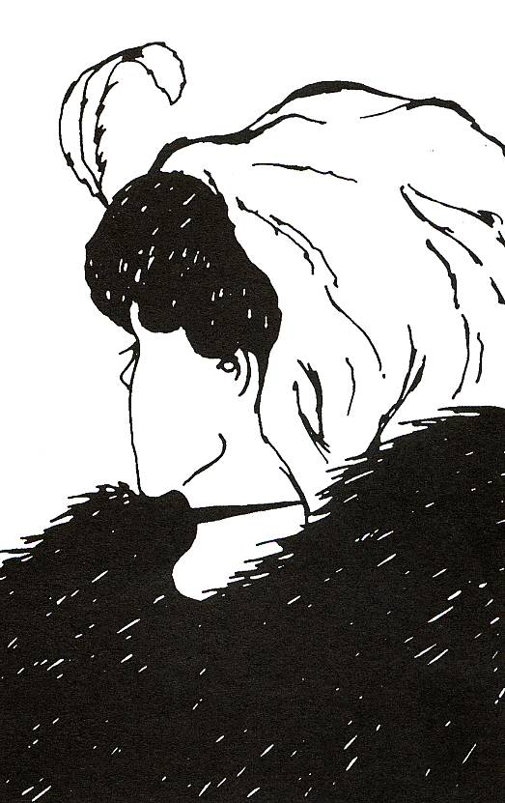
Honey & Mumford Learning Styles
This picture goes to show that we all have different preconceived ideas and concepts. Some of you see an old lady, others a young one, may be some of you cannot make heads or tails of it. The point is this: the fact we perceive this picture differently must surely mean some of us acquire information differently. If we acquire information differently, that must mean we learn in different ways. And having different learning sets means one instructional method for teaching will not cater for us all.

In addition, as individual, we might have different preconceived ideas about a certain topic but as a group we can learn a lot from each other and appreciate the different perspectives or points of view which then widen our understanding and learning.

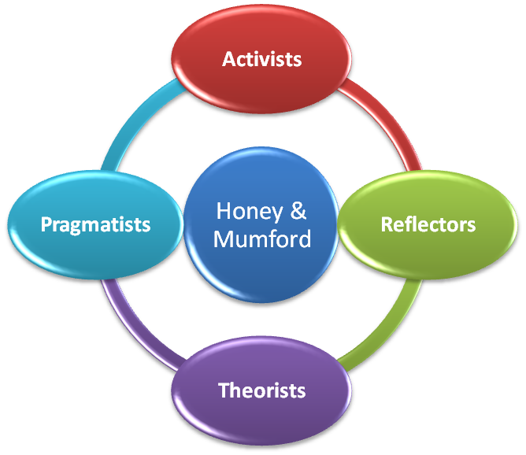
The way we acquire information depends on two things
- our built-in personality based preference
- the situation – different tasks require different approaches (e.g. most people would probably like to be shown and have a go at giving and intramuscular injection rather than reading or be told how to do it).

Whilst the following models are generally helpful, please remember that all people have a mixture of learning preferences and that sticking to a particular model rigidly might ‘pigeon hole’ people who are otherwise quite flexible. So use them as they were intended: as aids (and not as dogmas) to increase our understanding of people and not to ‘brand’ them permanently.

The final thing to remember is that there are no right or wrong types and they are not markers of intelligence; we’re all different and we all have our pros and cons. These differences are what make us strong as a group: the different perspectives and wealth of knowledge and experience furnished through group work outweighs anything one individual could possibly offer (even if a so called expert!).

Honey and Mumford’s work was based on original ideas by Kolb (1984). They postulated that learners sit somewhere along the lines of 4 different axes AND that the all rounded learner is one who can flexibly perform on all four axes depending on the context of his/her environment (= style flexibility). A lack of this flexibility results in learners struggling.

There is a questionnaire to help determine where you sit in relation to these four axes. It’s not free and can be purchased from http://www.peterhoney.com. Here is a bit about the different axes: maybe you can identify yourself without the questionnaire (a very crude way).
Axis | More about the Axis | How to recognise them | Their downfall | Teaching methods liked
Activists | Involve themselves fully & without bias in new experiences.  Open minded & Not sceptical, enthusiastic about anything new.  Days are filled with activity.  When one activity is dying down, they’re on the look-out for another | Famous sayings :  -“I’ll try anything once”  -“Sounds brilliant, let’s give it a go”  Enjoy the here and now and are dominated by immediate experiences.  Their days are filled with activity and are always on the go. When one activity is dying down, there on the lookout for another. | Act first & consider the consequences after.  Centre all the activities on themselves!  Thrive on challenge, but bored with implementation and long term consolidation (may not finish a job!) | Anything with Activity  -Brainstorming  -Role Play  -Simulations  -Demonstrations  -Practise  -Field Trips  -Group Work  -Games
Reflectors | Stand back and ponder about experiences.  Enjoy observing other people, adopt a low profile.  Act on the past, the present and the opinion of others.  When they say something, they offer a more ‘rounded’ reflection than others. | Famous sayings:  -“I’d like to think about it”  -“We need to be cautious”.  They often take the back seat in meetings and discussions.  They act, having taken different perspectives into consideration. | Thorough collection and analysis of data can delay reaching a definite conclusion.  They often postpone reaching a definite conclusion for as long a possible. So sometimes, decisions are never made! | They like to listen and read  -Reading  -Audiotapes  -Video/Film  -Seminars  -Group Discussion – they love them but often take a back seat observatory role
Theorists | Observe and make theories. Analyse and synthesise.  They think though problems in a vertical, step by step, logical way.  Go back to basic assumptions, principles, theories, models and systems. Their philosophy prizes rationality and logic. | Famous sayings:  - “If it is logical, it is good.”  -“Does it make sense?”  -“How does this fit in with that?”  -“What are the basic assumptions””  Always thinking of basic assumptions, the principles, the theories, the models and of systems currently in place. | They’re perfectionists: won’t settle unless things fit into a nice rational scheme.  Because they are always analysing, they often remain detached from the rest of the team.  Feel uncomfortable with subjective judgments, lateral thinking and anything flippant | They like to get their concepts right first.  -The lecture  -Structured group discussion  -Question & Answer sessions  -Reading – mainly concepts and theories rather than the attitudinal stuff that reflectors like to read
Pragmatists | Keen on trying out new ideas, theories & skills.  Return from management courses brimming with new ideas that they want to try out.  Essentially practical down to earth people & get on with things  Like practical decisions and problem solving | Famous sayings :  -“There is always a better way”  -“ How can I apply this to practice”  -“If it works it’s good”  Positively seek out new ideas; always taking the first steps in experimenting.  Problems are always seen as challenges. | impatient with ruminating and open-ended discussions | They like to put ideas into practise as soon as they get home.  -Demonstration & Practise  -Practical Workshops  - Field Trips?
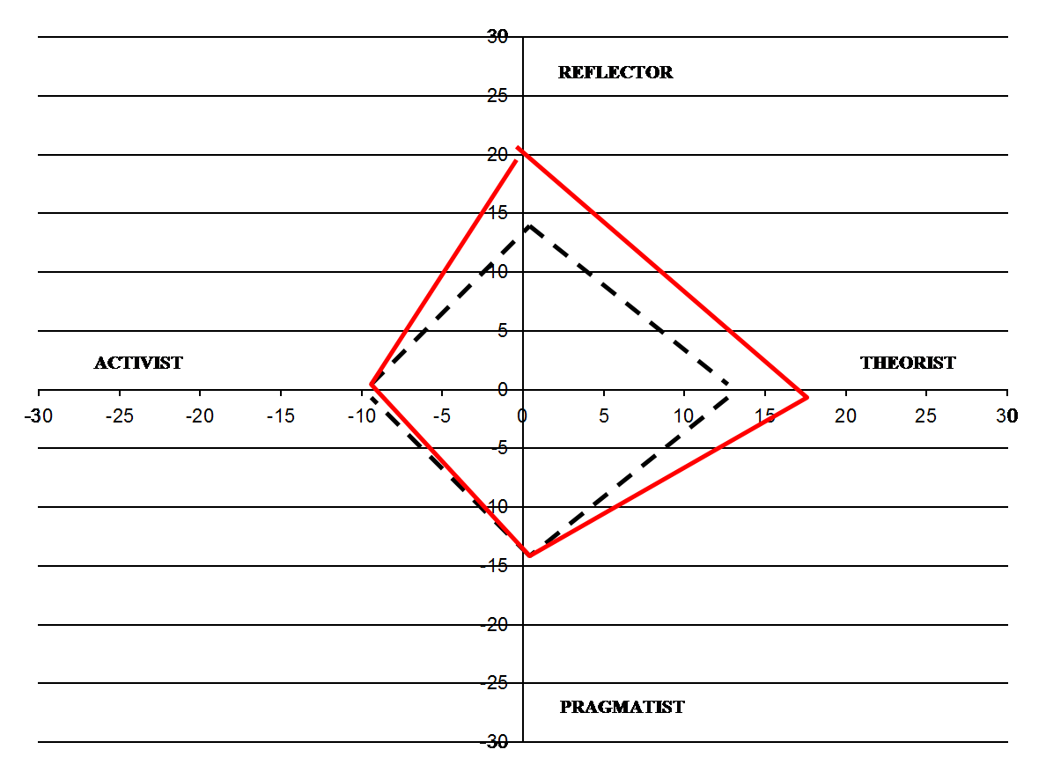

From the graph on the right, you can see that no-one fits neatly into just one of these four categories. We all have a bit of each but the question is to what extent.
This graph shows where the average person sits (outlined in black) and a specific example of a person with strong reflector-theorist preferences (in red).

How to Use This Model
You can use the model to
- Match your teaching style to that of the learner’s: i.e. using complementary methods
- Provide learning methods to boost a learner’s weaker areas: to make them ultimately a more ‘all rounded’ learner
- Identify potential problems specific learners might encounter: for example
Reflectors–Theorists: reflect and theorise so much that they end up in a state of ‘analysis to paralysis’
Activists - Pragmatists: end up doing things too quickly
Activists – Theorists: jump to conclusions too quickly
- Implement a variety of teaching methodologies when designing a course or educational session for a group of learners (who will inevitably come with different learning styles). Your session needs methods to cater for them all. So think what sorts of methods learners from each of the four axes might desire.
- Split a group of learners so that each subgroup has a mixture of people with different learning styles to promote understanding from different perspectives and thus create more ‘all rounded’ learners.
- Help allocate people to specific task groups in keeping with their learning style.
For example, if your team wants to implement a new service:
- group all the pragmatists in your team in a task group to figure out the practical problems one might encounter and how they might be resolved
- group the activists to implement a trial run and so on...

Alternatively: remember Kolb’s Learning or Experiential Cycle? (If not, read Pearl 3) You could split into four tasks groups each representing an arm of Kolb’s model.
- Experiencing: Activists are good at this
- Reflecting: Reflectors are good at this
- Conceptualising: Theorists are good at this
- Experimenting: Pragmatists are good at this
- allocate individual members to roles that complement their learning styles (either in education or in the work place environment). Activists are good at generating ideas, theorists for looking at current systems and how a proposal would fit in, reflectors on the possible effects of the ideas and pragmatists for trying them out and anticipating problems.

Visual-Auditory-Kinaesthetic (VAK) Model (1920s)
If you find Honey & Mumford’s learning styles all a bit too much, the VAK model is much easier to understand and apply in practice. VAK was a model originally devised in the 1920s to help teach dyslexic children but its wider applicability and relevance is now well established. VAK questionnaires can be found freely on the internet if you fancy finding out more about yourself.

The model is based on our senses: that we represent information in terms of three modalities – visual, auditory or kinaesthesia. Each of us has all three representation systems but usually one dominates; some people may be evenly balanced in all three.

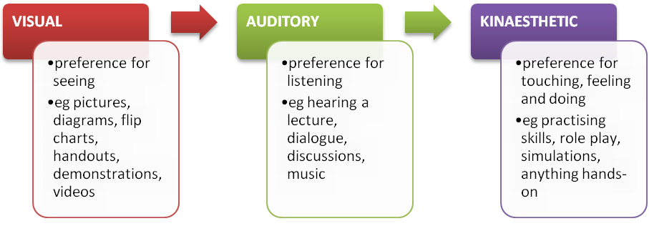
How Can I Assess Someone Without A Questionnaire?
Well, now you know the definitions from the diagram above, you can have a rough guess. This usually works okay if you know the person well.
Otherwise, you could do a couple of things:

- Listen to how they speak:

Visual | Auditory | Kinaesthetic
Often say:  “I see what you mean”  “Can you show me how..”  “Look, this is how you...”  “That seems great” | Often say:  “I hear what you’re saying”  “Tell me .....”  “Listen, this is how you...”  “That sounds good” | Often say:  “I know how you feel”  “Can I have a go”  “Why don’t you have a go...”  “I’d feel happy with that”

- Ask them some test questions:

Spelling: If I was to ask you to spell a word would you  - try to picture the word in your mind (V)  - try to sound out the word, or (A)  - write it down to see if it feels right (K) | Concentration: If you are studying or watching a TV programme that you have been looking forward to, which would you become distracted by  - untidiness/movement (V)  - by sounds/noises or (A)  - only if there was activity around you (K)
Meeting someone again: If you met someone that you had previously met a while back do you  - forget names to remember faces (V)  - forget faces but remember names or (A)  - remember best what you did together (K) | Contacting people on business: If you’re planning a meeting with a friendly work colleague would you prefer  - meeting face-to-face (V)  - talking on the telephone or (A)  - doing some activity (like walking) and discussing at the same time (K)
Reading: When reading a novel do you prefer  - descriptive scenes & pause to imagine them (V)  - reading a dialogue or conversation between people and hearing the characters talk (A)  - action stories or don't prefer to read at all (K) | Putting something together: If I ask you to put a small table together would you  - like to see the directions and pictures first (V)  - prefer me to tell you how to do, or (A)  - just get on with it; try to figure it out yourself (K)
Help with a computer: If you need help with a computer application would you prefer to
- see pictures and diagrams (V)
- call the help desk/neighbour/friend/shout at the computer or (A)
- keep trying until you succeed (K)

Now, which was the commonest type of reply – V, A or K?

How to Use The Model
- Use learning methods that match the learner’s preferred style e.g. visual media for visual learners, role play with kinaesthetics etc.
- Instantaneously build rapport with a learner by ‘mirroring’ the style they are displaying e.g. using the same verbs in their speech
- Optimising learning and memorising: Some say that you can optimise learning and memory if you present each key learning point in all three modalities. In a group you’d use all methodologies representing the three modalities anyway to cover the diversity within the audience. But you can extend this further by presenting each learning point in three different modal ways. A lot of schools for children do this these days and there is no reason why the same should not be applied to teaching adults.

Pearl 6: Blooms Taxonomy of Learning Objectives (1956)
To start off with, taxonomy is just a fancy term for classification. Bloom described three levels of learning: all learning can be split into either
- Knowledge (Cognitive Domain),
- Skills (Psychomotor Domain) or
- Attitudes (Affective Domain).

You can see from the diagrams below that each of the domains has further levels AND each taxonomy is hierarchical; by which we mean that learning at the higher levels cannot occur if one has not attained the lower levels: a development tree if you like. So, taking the “knowledge domain”, a trainee functioning at the ‘application’ level has to have mastered the material at the “remember” and “understand” levels. Let’s look at each of the domains in a bit more detail.

Cognitive (Knowledge) Domain
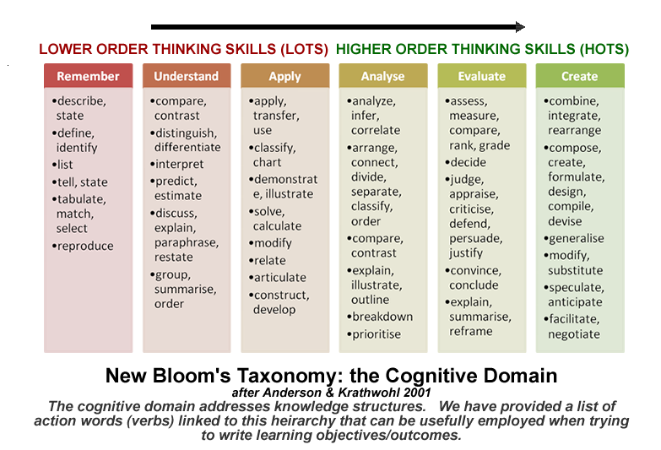
This domain refers to knowledge structures (simply ‘knowing the facts’ is at the bottom rung of this educational ladder). Originally, the labels devised by Bloom were nouns (for instance, knowledge as opposed to remember) but then converted later by Anderson (a former student of Bloom) into verbs to make them more active (and she rearranged the sequence too).

- Before we can understand a concept we have to remember^{*1} it
- Before we can apply the concept we must understand it
- Before we analyse it we must be able to apply^{*2} it
- Before we can evaluate its impact we must have analysed^{*3} it
- Before we can create^{*5} we must have remembered, understood, applied, analysed, and evaluated^{*4}
^{*1}recall of knowledge ^{*2}applying ideas/concepts to old and new situations ^{*3}teasing out important ideas ^{*4}deciding for oneself whether ideas are flawed or appropriate ^{*5}weaving new ideas with old to create something new

Affective (Attitude) Domain
You’ll probably remember from your early days in medical school that learning primarily centred on the knowledge (e.g. signs and symptoms of an acute myocardial infarct) and skills domains (e.g. examination of the cardiovascular examination). The acquisition of attitudes were primarily ignored and left to those apprenticeship years early on in your career. But attitudes are important and should form an equal (if not greater) part of the overall curriculum of learning right from the start. And besides, unlike knowledge, attitudes can’t be picked up from books or the internet. Perhaps it is because it is the most nebulous and hardest to evaluate of the three domains that it often gets overlooked?

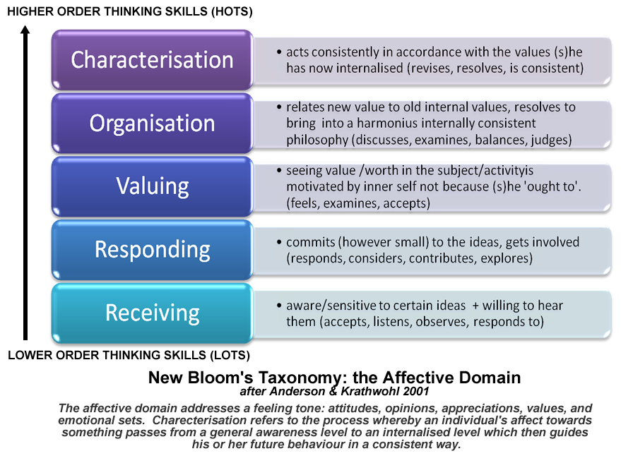

Psychomotor (Skills) Domain – The Conscious Competence Learning Model (1970s)
Bloom never got around to completing his work on the psychomotor domain. So, we’ll refer to a different model (The Conscious Competence Learning Model) that has gained significance and popularity. The origins of this model remain unknown, but it was first clearly defined by Noel Burch who worked for US Gordon Training International Organisation back in the 70s.

The best way to understand this model, which tries to explain how we acquire a skill, is to think back when you were first trying to learn to ride a bike or drive a car.
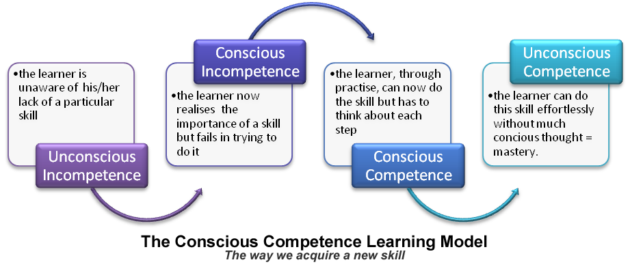
Learners can feel uncomfortable during the conscious incompetence and conscious competence phases. But uncomfortable feelings are good because they mean one is no longer in their comfort zone but on the journey to their desired state. Sometimes learners need to be reminded of this to help dampen any feeling of despair. Unconscious competence can only be achieved through practise, practise and practise (at the conscious competence stage). Once at this ultimate desired destination, any feelings of discomfort simply fade away.
How to Use These Models
- As originally intended, these can help us formulate our objectives for a teaching session, course, programme or curriculum – what do we wish to focus on (in terms of knowledge, skills and/or attitudes) and to what level. If you’re ever stuck when trying to figure out your aims and objectives, always consider mapping them out in relation to knowledge, skills and attitudes.
- As with any checklist, it helps to reduce the risks of overlooking some vital aspect of an educational session. Considering the knowledge, skills and attitudes (and their sublevels) of a particular topic forces us to take a holistic approach.
- Help us identify where trainees are in the learning process and therefore help identify their needs. Taking the clinical area of sexual health as an example: is the trainee’s knowledge up to scratch or do they now need to start focussing on practising taking a sexual history or examination skills or do we need to look at their attitudes towards sexual practises and moral views?
- Help us plan a set of training sessions in a constructivist way: building on knowledge first, then skills and then attitudes (and progressing through the taxonomy of each one before moving to the next).
- Help an educator realise what (s)he needs to do to move a trainee onto the next learning level within a domain – even the trainees that seem to be excelling. The levels within the domains can be used to provide a basis for questioning that ensures trainees progress to the next level.
- Help us plan the learning process itself: selecting methods/activities to match the objectives. For example, if one wanted to teach on “how to examine the knee joint”, there is probably little point in just explaining how to do it or providing written instructions. Practise is going to be the key (practise is always the gold standard when teaching skills).
- Help us tell our trainees exactly what we expect from them; what one needs to achieve in terms of knowledge, skills and attitudes and to what level.
- Help us design evaluation to check we have achieved what we are trying to achieve. One can design evaluation questions to see at which level trainees now sit after your educational session
- You can use the taxonomy within the affective domain to provide you feedback on your performance as an educator. Look at the behaviour of your learners in your session. Are they, for example, actively displaying their own internal value sets and questioning you (the ‘responding’ level)?

Pearl 7: Miller’s Pyramid/Prism of Clinical Competence (1990)
Psychologist George Miller proposed a framework for assessing levels of clinical competence back in 1990.
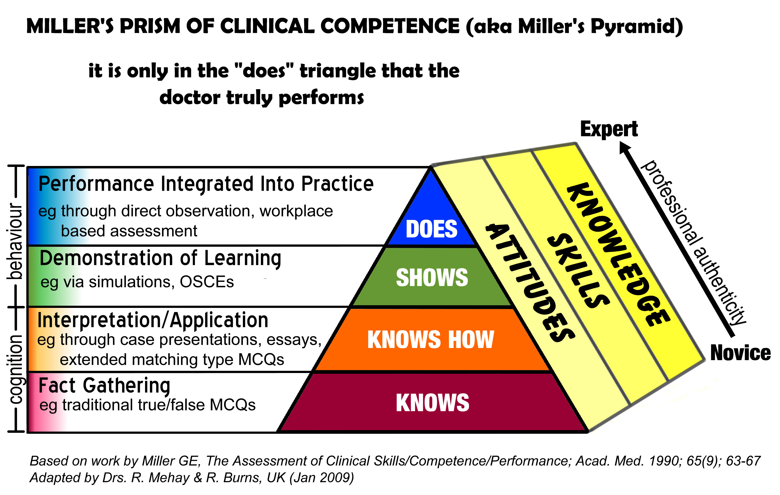

- Knows : knows some knowledge
- Knows how: knows how to apply that knowledge
- Shows: shows how to apply that knowledge
- Does: actually applies that knowledge in practise

In the pyramid, the lower two levels only test cognition (or knowledge) and this is the area where inexperienced trainees (or novices) usually sit: for example, they either “know” something about a mental state examination or they “know how” to do a mental state examination.

The upper two levels test behaviour: can they apply what they know into practise? Going back to the previous example: can they “show” how to do a mental state examination or do they actually “do” a mental state examination in practise?

Research shows that the cognition zone (“knows” or “knows how”) correlates poorly with the behaviour zone (“shows” or “does”): a trainee who knows how to do something doesn’t necessarily mean that they will do that in daily practise. But it’s important that trainees do what they know in practise otherwise there’s no point learning it. To think of it another way: would you get into a sports car with a person if they said they’d only read how to drive the car or one that drove it on a daily basis to work (and had a clean driving license for the last 5 years)?

So, if you want such trainees to apply their learning into real daily life (as opposed to it lying dormant in their brains) you need to use methods that will encourage them to progress through the “shows” and “does” zones (behaviour). For the “shows” zone this often involves artificial simulation exercises like them demonstrating it to you or via OSCEs and patient simulations. The “does” zone invariably involves looking at what happens in the real work place environment (like sitting in and observing them or using video recordings of real consultations).

Originally, Miller represented his framework as a 2 dimensional pyramid. We’ve adapted it to include the knowledge, skills and attitudes domains of learning and thus called it “Miller’s Prism”. Dent and Harden have added a 5th level called “Mastery” that sits above “Does” to make the distinction between one who can perform a skill with competence to one who can perform it in a expert or masterful way.

How to Use This Model

- Traditionally, the model has been used to match assessment methods to the competency being tested. So, if you wanted to see how good a trainee is at ‘examination of the knee’, offering multiple choice questions might demonstrate they know about it but not that they can actually do it. To test the latter the assessment method of choice might include an OSCE style station to examine the knee or better still, direct observation in the work place itself.

Remember, trainees can get away with “brushing up” their knowledge and skills before an MCQ/essay type exam (which then, as we all know, fades after that exam). However, this is less likely with assessment systems matched to the “behavioural zones” which therefore makes them more valid and better preparation methods for professional life.
- The model can help you formulate objectives for a particular teaching/learning session: by forcing you to think carefully about what you are trying to achieve. Take the example of an educational session on cardiac risk. The following are examples of objectives and the level of Miller’s prism being represented:
- Understanding what is meant by cardiac risk and why it’s important (KNOWS)
- Knowing what to do if the risk is too high (KNOWS HOW)
- Being able to demonstrate the use of the cardiac risk calculator (SHOWS)

- In a similar way you can use it to help design a course programme. For instance, if you wanted to do a half day workshop on “shoulder joint injections”, you could design an instructional session reflecting some of the levels of Miller’s prism:
For example
  - 9-9.30am Revisiting the Anatomy of the Shoulder (KNOWS)
  - 9.30-10am Pitfalls to remember (KNOWS)
  - 10 – 10.30 The Shoulder Joint Injection Algorithm (KNOWS HOW)
  - 10.30-11am Break
  - 11-1230 Practising the technique on dummies (SHOWS)
  - 1230-2pm Lunch

Note: if you want to test at the ‘does’ level you would have to consider practical work-place based sessions as you often see on family planning, cervical smear and child health surveillance courses. But there might be other methods too like a review of video consultations with real patients (if your objective was to look at communication skills).
- Finally, you can use the model to tailor a teaching session to the level of the trainee. For instance, if you were delivering a tutorial on communication skills:
- For those trainees in their early stages you might concentrate on the basic building-block knowledge domain like: why it is important to ascertain patient’s ideas, concerns and expectations and what the evidence says (KNOWS).
- For those more experience (or the same trainee but later on) you might consider how they might actually elicit ideas, concerns and expectations: what phrases they might use (KNOWS HOW).
- When they’re even more experienced, then you might look at in vivo performance like: reviewing videos of actual consultations with patient (DOES)

Pearl 8: The Last Pearl - Gagné’s 9 Events of Instruction (1996)
Gagné’s nine events of instruction is a good general step by step guide on how to deliver any educational session.

- Gain attention of your learners. This is to create a state of ‘readiness’ in your learners for learning. Examples of how you might do this include: an analogy, anecdote, paradox, or article. You really need to ‘hook’ them firmly before any educational session otherwise why should they engage?
- State session’s objectives. Provide an outline of your session plan in a visual form (e.g. mindmap or diagram) so that they can see where you are going and what to expect. It also provides a framework onto which they can hang new learning. You can also create powerful expectancies via your objectives which will hopefully ‘hook’ them further.
- Stimulate recall of prior learning. Start off from a level playing field and establish what they already know so that you can use that as a springboard for new learning and weave into it any new learning.
- Highlight key features. Emphasise the key messages in your session and signpost them in a variety of ways (e.g. through pictures, sounds etc.). This will maintain attention and aid recall.
- Structure the learning. Break the learning into small manageable chunks always starting from the simple and gradually moving to the more complex. Check understanding periodically and be prepared to go back a step if there is any difficulty.
- Encourage activity. Encourage learners to question, discuss and demonstrate. Help them create links and associations. This will a) tell you to what level they are learning from your session b) enable you to correct where necessary c) promote understanding and d) maintain attention through active participation.
- Provide feedback. Once learners are actively involved (point 6), reinforce messages if they’re on the same wavelength as you but correct if they are not.
- Assess performance. Evaluating progress helps you: a) check they have got the gist of what you’ve been trying to convey b) to strengthen any learning and c) to ensure you’ve done your job well. An evaluation form is just ONE way of doing this.
- Enhance retention, learning transfer & signalling future learning – summarise the learning that has occurred and then set future homework to ensure the learning is transferred and applied into their real worlds. Good facilitators will arrange a further follow up session to see how that application has gone (fine tuning further if necessary).

Further Resources on Educational Theory:
Bradford VTS: http://www.bradfordvts.co.uk (click online resources; section 03.7)
GPtraining.net: http://www.gp-training.net

Acknowledgements
We thank the following authors for kindly providing permission for reproducing some of their work:
- Gerald Grow: The SSDL model; more information available at: http://www.longleaf.net/ggrow

Dorothy Billington: Billington’s 7 Characteristics of Highly Effective Adult Learning Programs; more information available at http://www.newhorizons.org/lifelong/workplace/billington.htm

References
- Anderson, L. W., & Krathwohl, D. (Eds.) (2001). A taxonomy for learning, teaching and assessing: A revision of Bloom's taxonomy of educational objectives. New York: Longman.
- Bales, R. F. (1965) 'The equilibrium problem in small groups' in A. P. Hare, E. F. Borgatta and R. F. Bales (eds.) Small Groups: Studies in social interaction, New York: Knopf.
- Billington, Dorothy D. (1988) Ego Development and Adult Education. Doctoral Dissertation, The Fielding Institute. Dissertation Abstracts International, 49 (7). (University Microfilms No. 88-16, 275).
- Billington, Dorothy http://www.newhorizons.org/lifelong/workplace/billington.htm accessed 17.2.09
- Bloom: Taxonomy of Educational Objectives: The Classification of Educational Goals; pp. 201-207; B. S. Bloom (Ed.) Susan Fauer Company, Inc. 1956.
- Brookfield S. Understanding and Facilitating Adult Learning: a comprehensive analysis of principles and effective practices Milton Keynes: Open University Press, 1986
- Brookfield, S. D. (1990). Understanding and facilitating adult learning. San Francisco: Jossey-Bass.
- Caine, R.N., & Caine, G. (1991). Making connections: Teaching and the human brain. Alexandria, VA: Association for Supervision and Curriculum Development.
- Candy, Philip C. (1987). Reframing research into 'self-direction' in adult education: A constructivist perspective. Doctoral dissertation, University of British Columbia. Ottawa: National Library of Canada, Canadian Theses (Microfiche: 0-315-40011-0).
- Croce, Benedetto. The Philosophy of Giambattista Vico. Trans. R.G. Collingwood. London: Howard Latimer, 1913
- Curry. Cognitive and Learning Styles in Medical Education. Academic Medicine 74(4): 409-13 1999
- Dent J and Harden R. A Practical Guide for Medical Teachers Edinburgh: Churchill Livingstone, 2001
- Dewey, John. (1938). Experience and Education. New York: Macmillan.
- Dewey, John. (1966). Democracy and Education. New York: Free Press.
- Duffy, T.M & Cunningham, D. (1996). “Constructivism: Implications for the design and delivery of instruction.” In Jonnasen, D. (ed.) Handbook of research for educational communications and technology, Mahwah, N.J.: Lawrence Erlbaum Associates pp.170-198.
- Fox, D. (1983). Personal theories of teaching. [British] Studies in Higher Education, 8 (2), 151-163.
- Dewey, J. (1938) Experience and Education Kappa Delta, then Collier, New York.
- Gagné RM 1988 Principles of Instructional Design, New York, Holt, Rinehart and Winston
- Gagné, R. and K. Medsker (1996). The Conditions of Learning: Training Applications. Forth Worth: Harcourt Brace.
- Gardner Howard, Frames Of Mind (1983),
- Gibbs G (1988) Learning by Doing: A guide to teaching and learning methods. Further Education Unit. Oxford Polytechnic: Oxford.
- Grow, Gerald O. (1991/1996). "Teaching Learners to be Self-Directed." Adult Education Quarterly, 41 (3), 125-149. Expanded version available online at: http://www.longleaf.net/ggrow .
- Harkin, Gill Turner, Trevor Dawn: Teaching Young Adults: A Handbook for Teachers. Published by Routledge, 2001 ISBN 0415222834, 9780415222839
- Hershey, P., Blanchard, K.H. (1969), "Life cycles theory of leadership", Training and Development Journal, Vol. 23 No.5, pp.26-34.
- Hershey, P., Blanchard, K.H. (1993), Management of Organizational Behavior, 6th ed., Prentice-Hall, Englewood Cliffs, NJ, .
- Honey P and Mumford A. The Manual of Learning Styles Maidenhead: Peter Honey, 1986
- Houghton, R.S. (2004. March 17). Communities Resolving Our Problems (C.R.O.P.): the basic idea: Bloom's Taxonomy - Overview. Retrieved March 12, 2005 from http://www.ceap.wcu.edu/Houghton/Learner/think/bloomsTaxonomy.html
- Keller: ARCS model; http://www.arcsmodel.com/Mot%20dsgn.htm (accessed 17.2.09)
- Kolb D. Experiential Learning New Jersey: Prentice Hall, 1984
- Knowles, M.S. (1980) The Modern Practice of Adult Education: From Pedagogy to Andragogy. (2nd edition) New York: Cambridge Books.
- Knowles, M. et al (1984) Andragogy in Action. Applying modern principles of adult education, San Francisco: Jossey Bass. A collection of chapters examining different aspects of Knowles' formulation.
- Knowles, M. S., Holton, E. F., & Swanson, R. A. (2005). The adult learner (6th ed.). Burlington, MA: Elsevier Butterworth-Heinemann. (Original work published 1973)
- Maslow, A Theory of Human Motivation, Psychological Review 50(4) (1943):370-96.
- Maslow, Abraham (1954). Motivation and Personality. New York:. Harper. p. 236.
- Mezirow, Jack. 1991. Transformative Dimensions of Adult Learning. San Francisco: Jossey Bass.
- Miller GE. The assessment of clinical skills/ competence/ performance. Acad Med (1990);65:s63-s67.
- Piaget, Jean. (1950). The Psychology of Intelligence. New York: Routledge.
- Piaget, J. (1973). To Understand is to Invent: The Future of Education. New York, Grossman Publishers.
- Pratt, D.D. (1988). Andragogy as a relational construct. Adult Education Quarterly, 38(3), 160-181.
- Seels and Glasgow (1990). Exercises in instructional design. Columbus OH: Merrill Publishing Company.
- Turner, J., & Paris, S. G. (1995). How literacy tasks influence children's motivation for literacy. The Reading Teacher, 48(8), 662-673.
- Vella, J. (1994). Learning to Listen, Learning to Teach. San Francisco: Jossey-Bass, 3-22.
- Vygotsky, L. (1934). Thought and Language. Cambridge Mass: MIT Press.
- Vygotsky, L. S. (1978). Mind in Society: The Development of Higher Psychological Processes. Cambridge, MA, Harvard University Press.
- Windschitl, M. (2002). “Framing constructivism in practice as the negotiation of dilemmas: An analysis of the conceptual, pedagogical, cultural, and political challenges facing teachers.” Review of Educational Research. Vol. 72. No. 2. pp. 131-175.

